DIGITS
KS1 – 2002 Papers
1.
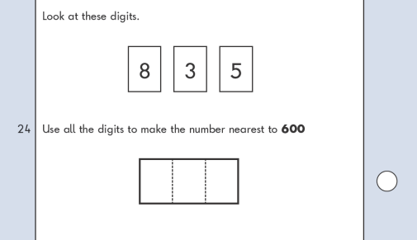
KS1 – 2003 Paper 2
2.

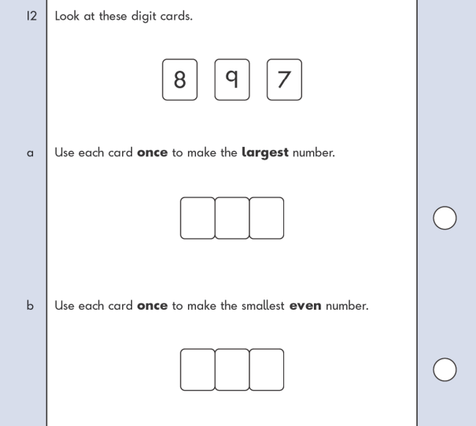
KS1 – 2004 Paper 1
3.

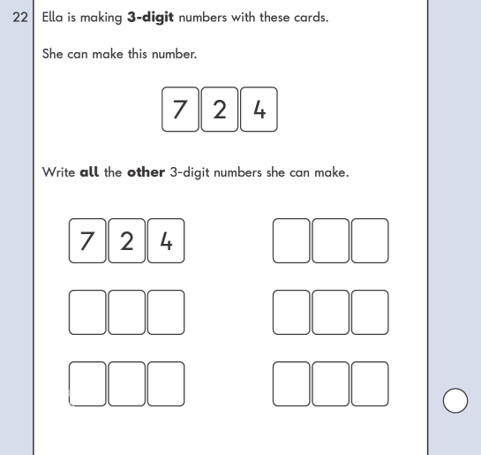
KS1 – 2004 Paper 2
4.

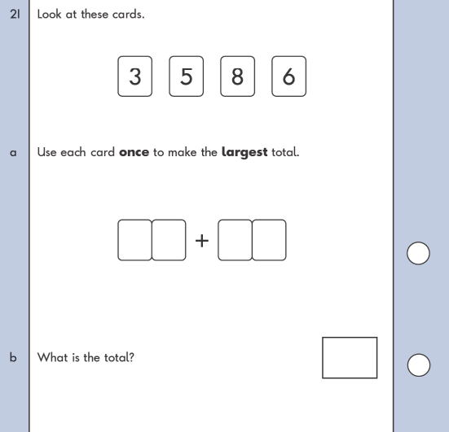
KS1 – 2016 Paper - Reasoning
5.
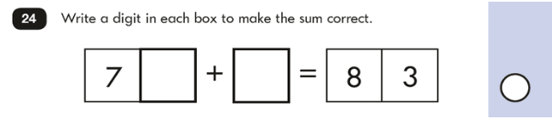

KS1 – 2019 Paper – Reasoning
6.
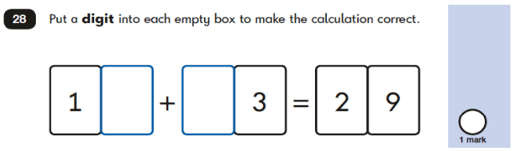
KS1 – 2022 Paper – Reasoning
7.
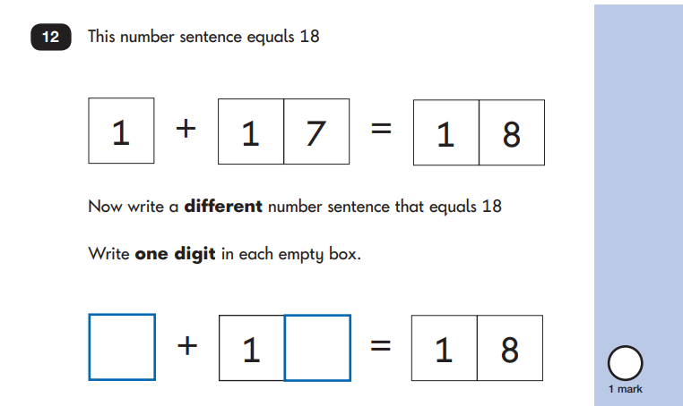
8.
